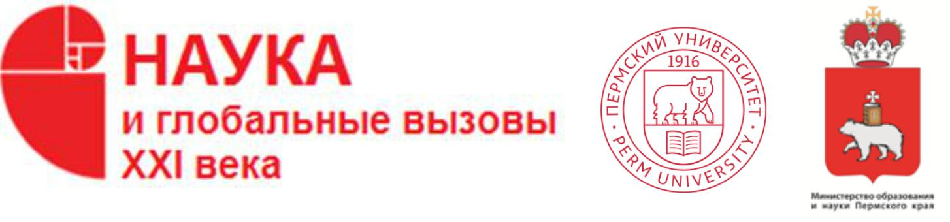

PERM NATURAL SCIENCE FORUM

"Science and global challenges of the XXI century"

Perm, 2021

Main activities (project *)

Perm Natural Science Forum

"Science and global challenges of the XXI century"
18-23 October

Autumn session
Event title | Date of the event | Summary
International Scientific Conference  "Smart Innovations and Technologies” | 18-19  October | The conference is aimed at sharing, exchanging and advancing new ideas, approaches, innovative technologies in various fields involving  · Corpus Linguistics  · Computational Linguistics  · Digital Technologies in Language Teaching and Translations Studies  · Innovations and Technologies in Literary Studies  · LSP in Digital Society  The conference is an interdisciplinary platform for researchers, educators and practitioners to discuss the most recent trends, innovations, challenges and their solutions.
All-Russian Conference with international participation "Fundamental and applied aspects of bioinformatics, biotechnology and subsoil management" | 18-20  October | The conference is aimed at discussing the problems of development of bioinformatics and approaches to analysis, presentation of large data sets in subsoil management, biotechnology, biomedicine and ecology, as well as the role of IT technologies in the development of these areas.
All-Russian Scientific and Practical Conference of young scientists with international participation  "Mathematics and interdisciplinary  research -2021" | 18-20  October | The conference is aimed at creating new scientific links between young scientists from Russia working in various scientific disciplines and using mathematical methods and information technology.  Sessions:  fundamental problems of mathematics, mechanics and computer science;  links between natural sciences in the modern world;  mathematical modeling: theory and models in economics, geography, biology, ecology, medicine, psychology and social sciences;  information systems and software in natural and human sciences;  history of mathematics, mechanics and computer science, etc.
The Sixth All-Russian Scientific and Practical Conference  "Artificial intelligence in solution relevant social and  economic problems XXI century" | 20-21  October | The purpose of the conference is to bring together specialists working in various fields of applied algorithms of neural networks and intelligent systems; discussion and generalization of the experience of theoretical and practical developments; discussion of the development and application of artificial intelligence methods for solving problems of knowledge extraction, pattern recognition, optimization, forecasting and control of objects, processes, phenomena.
All-Russian Scientific and Practical Conference "Infocommunications: safety, reliability, efficiency" | 20  October | The purpose of the conference is to bring together the efforts of scientists and practitioners to improve the safety, reliability and efficiency of the organization, implementation and use of information and communication systems and networks in scientific, industrial, educational spheres, as well as in the mass use of infocommunication services by people.
All-Russian Scientific and Practical Conference  "Perm system of the Earth Globe - 180 years" | 20  October | The purpose of the conference is to bring together the efforts of scientists and practitioners aimed at identifying common patterns, manifestation and development of natural dynamic processes in the Main Permian field of the globe in order to forecast and search for minerals, ensure sustainable development of regions and life safety.  The conference is planned to discuss modern achievements in the following areas:  1. Geophysical research in the search for mineral deposits and assessment of their technogenic impact  2. Structural-tectonic, geological and hydrogeological structure of the Priuralsky segment within the boundaries of the Main Permian field.  3. Petrological, lithological, stratigraphic and paleontological features of Permian deposits  4. Regional, intra-basin and inter-basin correlation of Permian sedimentation basins, primarily in Russia, USA, Canada, Poland, Germany, China.  5. Regularities of development and distribution of natural dynamic processes in the rocks of the Main Permian field  6. Research on the techno genesis and interaction of engineering structures with the geological environment within the Main Permian field, including along the routes of trans-regional linear structures (high-pressure gas pipelines, railways)
Scientific School "Historical and Cultural Heritage in the Digital Dimension" | 20-22  October | The focus of the autumn school will be the study and development of modern digital methods, technologies and tools for the implementation of scientific and popular science research aimed at preserving and studying the historical and cultural heritage and the formation of a digital humanitarian environment in the Perm region and Russia.  This event is aimed at creating new links between scientists and specialists, young scientists of Russia from various fields of the humanities and natural sciences, and to popularize the historical and cultural heritage of the Perm region, historical and cultural memory, develop educational activities, and improve the museum information environment. The scientific school provides for lectures and master classes in three thematic areas from the field of application of information technologies in the preservation and representation of historical and cultural heritage and the formation of a developed information environment of the museum.
All-Russian Scientific and Practical Conference "Modern Studies of Geographical Systems" | 20-21  October | The purpose of the event is to unite Russian and foreign researchers of geographical systems to increase the authority of knowledge and science, to determine the role of research in scientific schools of the geographical faculty of Perm University in the development of the foundations of rational environmental management. Master classes by leading geographers will be held as a part of the scientific and practical conference.
International Scientific and Practical Conference "Economic Science in the context of Global Challenges: Realities, Forecasts" | 21  October | The Conference will consider the key aspects of the modern economy, which has entered a phase of global uncertainty. Conference speakers will present their vision of the current state and development forecasts in such areas as the global and regional economy, management, marketing and innovation, finance, forensics and audit, economic security and international integration, Big Data, cryptoeconomics and blockchain.
All-Russian Scientific-practical conference "Language of modern science" | 22  October | The aim of the conference is to discuss the features of modern scientific communication with new discursive factors contributing to the specificity of preparation and presentation of scientific knowledge in the XXI century.  Sessions of the conference: the semantic structure of a modern scientific text; new forms of scientific communication; national traditions of academic writing in the context of the globalization of scientific communication; stereotype and creativity in the scientific text; communicative activity of a scientist and the importance of scientometrics.
All-Russian Conference with international participation "Man in the world, world in man: through innovation to sustainable development" | 22-23  October | The conference continues a series of 23 international and all-Russian conferences. The goal of the conference is to integrate the efforts of philosophers, psychologists, sociologists, specialists in the field of cultural studies and organization of work with young people to discuss issues related to the social and humanitarian dimension of human development, society and technology on the path to sustainability. The conference format is intramural and extramural, with the use of videoconferencing.

