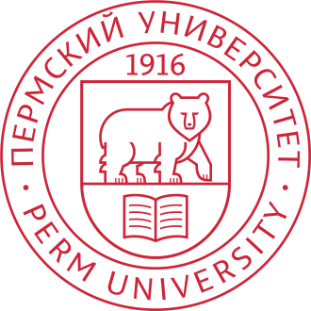

Call for Papers
"International Perm Forum "Science and Global Challenges of the 21st Century" is an international forum to be held in Perm, Russia, October 18 – November 23, 2021. The event will be organized both online and offline. The main goal of the forum is to discuss the tasks and problems faced by science and education and the whole society in the context of globalization of civilization processes on the planet. The forum also aims at finding solutions and paths for implementing potentials, fighting threats, and controlling risks. Global challenges, which determine the main trends in the development of social and economic life of mankind in the XXI century, require the integration of efforts of specialists in various fields of knowledge, production and economy. That is why the main principle of the forum's program is interdisciplinarity, formation of end-to-end innovation chains: fundamental and applied research, technology development, implementation, and wide application of smart innovations and information technologies.

The main events of the Forum will take place from October 18 to October 23, 2021 in Perm State University, Perm, Russia.

We are pleased to invite you to present your papers in English at the Forum "Science and Global Challenges of the 21st Century ". We welcome contributions focusing on Innovation and Smart Technology applied to various fields of soft and hard sciences, including but not restricted to the following:
Smart Approaches in Information Technology and Computer Science;
Innovations and Smart Technologies in Mathematical Modelling;
Innovations and Smart Technologies in Geosciences;
Innovations and Smart Technologies Biology;
Innovations and Smart Technologies in Linguistics;
Innovations and Smart Technologies in Social Studies;
Innovations and Smart Technologies in Law;
Innovations and Smart Technologies in Historical studies;
Innovations and Smart Technologies in Teaching;
Innovations and Smart Technologies in Economics.

Articles in English, 7-15 pages, approved by peer-reviewers and meeting the requirements of Springer Proceedings Guidelines for Authors, will be published in the book series «Smart Innovation, Systems and Technologies», submitted for indexing in Scopus and Web of Science, and located in the SpringerLink digital library. All submissions will be evaluated for relevance, originality, importance, and clarity, and will undergo double-blind peer review. Once articles are accepted for publication, authors must complete a publication consent form and pay the registration fee 20,000 rubles (the price in Euro depends on the exchange rate).

To submit or upload a paper please go to http://permforum.psu.ru/openconf

Important Dates

Paper Submission: June 1, 2021.
Notification of Acceptance: July 1, 2021
Camera-ready Submission: July 15, 2021
Payment of Registration and signing the author’s agreement, to ensure the inclusion of an accepted paper in the conference proceedings: August 1, 2021.

Contacts:
Program Chair: Alexander Shkaraputa, shkaraputa@psu.ru
International Communication Chair: Ekaterina Isaeva, ekaterinaisae@gmail.com
Project manager: Natalya Petrova, nap@psu.ru

Website: http://math.psu.ru/?lang=en .
The Forum information will be also available in Perm State University Website ПГНИУ http://en.psu.ru/ and in Facebook https://www.facebook.com/universityperm

